**2020 IISE-HSH Student Simulation Competition**

**Surgical Center Optimization Case Study**

**Team Members: Nicolette Somers, Jackie Lu, Sam Pertas, Peng Ying-Chih**

**Industrial and Systems Engineering, The University of Florida, Gainesville, FL 32611, USA**

**Executive Summary**

OR’s generate around 70% of a hospital’s revenue. The purpose of our project is to increase the revenue of the OR department while also improving staff utilization. We focused on using a block scheduling approach to schedule the same type of surgeries back-to-back in the same OR. In general, reallocating surgeries based off of a block schedule allows for a resource reduction while maintaining patient throughput. Using this block scheduling approach, we ran through all scenarios of different counts of support staff and identified the most efficient recommendation was having a count of 2 Circulation Nurses, 1 PreOp Nurse, 2 Maintenance Group, 2 Scrub Nurse, and 1 PACU Nurse. Having this staff configuration and scheduling system provided optimization in our definition of effective with $80,191 in earnings, utilization increasing up to 39.63%, 24 cases completed, and 200 minutes of overtime. Without investing significantly in new equipment or other resources, we were able to make improvements across the board in the surgical center.

**Problem Statement**

Scheduling surgeries for operating rooms in a medical facility is extremely complex. The OR schedule directly impacts the overall efficiency of the system. Healthcare facilities are continuously looking for ways to decrease hospital costs while maintaining the same quality of care. Operating Rooms are the most costly resource in a hospital, and for each lost minute in an operating room it costs on average $60. Lost revenue at a hospital can help be mitigated by successfully scheduling surgeries. FlexSim simulation model is utilized to evaluate how the system performs with different surgery schedules.

## **Modeling Assumptions:**

Surgeons in the simulation model can complete multiple subsequent surgeries in a day. In an actual healthcare system, back to back surgeries typically results in delays of scheduled/Add On surgeries. Our model uses provided expected turnover and surgical times to resemble and simplify actual surgical time.

Another assumption is that three operating rooms and other physical resources (wheelchairs, desks etc.) are sufficient for the 24 surgeries that were scheduled. The model increased Operating Room utilization as an objective but changing the facility layout is not one of the objectives. Facility optimization could potentially result in more cases completed but will not be explored in this model. Break-times and lunch allocations are not considered in this model; it is assumed that all staff groups are working the entire time. This model does not consider the realistic aspects of break/lunch variability.

Shift schedules are not included in the model. There is no restriction on overtime which simplifies Staff resource busy time. This model does not consider the variance or probability of staff not showing up for their shifts or showing up on time for their shifts. Nor does the model go in depth with shift changes and the delays it could potentially cause in the start of the next surgery. All staff resources starting the surgery must stay until the patient is discharged. Other model assumptions involve block case prioritization, work continuity during overtime, and patient arrival at 5:30 AM despite center time opening at 6AM.

# **Experimentation and Conclusions**

Our team focused on using block scheduling to allocate surgeries to each OR. Block scheduling is an OR scheduling policy to assign a block of OR time to certain surgeon group for a particular period of time of the day. According to previous studies, this policy has been shown to be effective in improving overall OR performance. Often, block scheduling also reduces resource requirements by reallocating surgeries into blocks.

To implement block scheduling to this case study, we arranged Case Scheduling Order and OR Suite columns in Surgical_Cases_Master file to assign blocks of OR time to surgeries of the same Block Group. Surgeries of the same Block Group would be assigned to the same OR Suite in consecutive order, those with higher Expected Earnings would be given priority. To make sure the total usage of all ORs are distributed evenly, we summed up the surgery time, which by our assumption is the sum of Expected Surgical Time and Expected Turnover Time, of the assigned surgeries for each OR, and even those out among three ORs.

Among numerous experiments using block scheduling approach, we achieved expected earnings of $80,191 and overtime of 200 minutes with 24 surgeries, which we believe is a good balance point between achieving high earnings and maintaining high quality of patient care (low staff overtime).

Below are some of the major results and descriptions of the model:

1. Applying the scheduling system and OR suite decisions stated above, we gain this output:

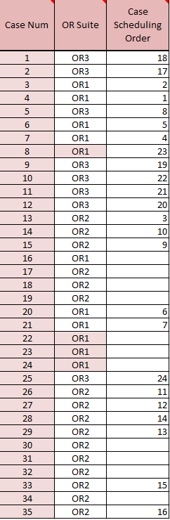

Figure 1: Scheduling Output

1. This is the number of staff we believe is the most efficient for those scheduled surgeries

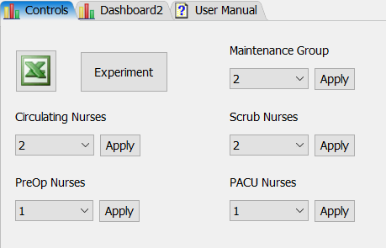

Figure 2: Optimal Staff Output

1. Earnings, overtime, and number of cases

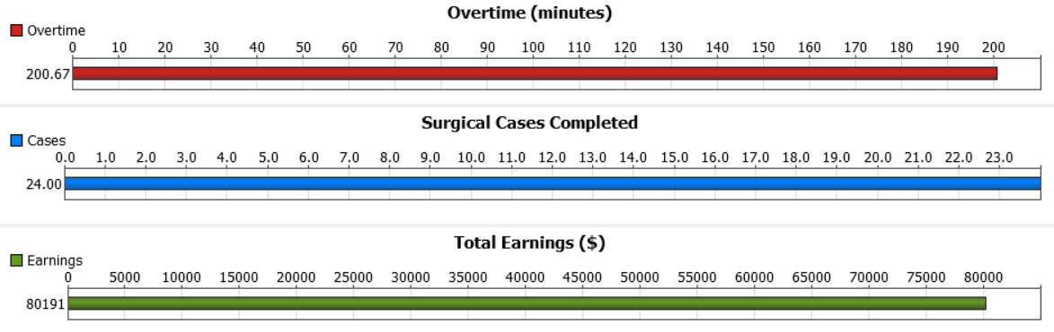

Figure 3: Optimal Results

1. Cumulative Staff Utilization:

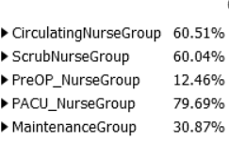

Figure 4: Staff Utilization

1. OR utilization: Around 70%



Figure 5: OR Utilization

To fully understand the significance of our recommendation, we will compare our final model with the base model provided to us. The original model configuration came equipped with maximum staff count and an arbitrary scheduling system.

Table 1: Base Model Compared to Optimal Model

|  |  |  |
| --- | --- | --- |
|  | Base Case Model | Our Optimal Model |
| Number of Completed Cases | 18 | 24 |
| Total Earnings | $53,821 | $80,191 |
| Overtime (minutes) | 158 | 200 |

Staff percent utilization also increased for Circulating Nurses (+39.69), Scrub Nurses (+39.43%), PreOp Nurses (+9.34%), PACU Nurses (+51.83%), and Maintenance (+13.29%). Overtime did increase by 42 minutes in our model, but we deemed the benefits of 49% increase in profit and completing 6 more cases outweighed the slight overtime increase.

# **Verification and Validation**

Model verification and validation are critical in the successful development of a simulation model. We found different practical approaches to verify and validate our model for the Keller Augmenting Surgical Center.

The following measures were taken to ensure that the Flexsim simulation model is an accurate representation of a real-world system, functioning correctly, and performing as intended for verification and validation purposes.

Verification: Verification is determining whether the simulation is working as intended. WE implemented two methods of verification: animation and replication (Verification and validation of simulation models, IEEE Conference Publication 2008)*.* Upon observing the Flexsim 3D model animation feature, we are able to verify that the simulation follows the excel Master Sheet properly. 10 replications of the simulation model were completed. All replications yielded consistent output data therefore verifying the model works as intended.

Validation: Validation is determining if the conceptual model is an accurate representation of the actual system being analyzed. In this section we will elaborate on two methods of validation: comparison to other models (Verification and validation of simulation models, IEEE Conference Publication 2008).

To confirm that our findings here were the optimal output, we ran 675 scenarios with the developed OR suite decisions and scheduling and built a linear model with the scenario data. Using the statistical programming software, R, we developed this linear model with earnings as the dependent variable and support staff count as the explanatory variables:

lm(formula = Earnings ~ CirculatingNurse_Count * PreOpNurse_Count *

MaintenanceGroup_Count * ScrubNurse_Count * PACUNurse_Count,

data = regressionData)

Before we take a look at the coefficient value of this model, the model was analyzed to see if it was an appropriate fit.

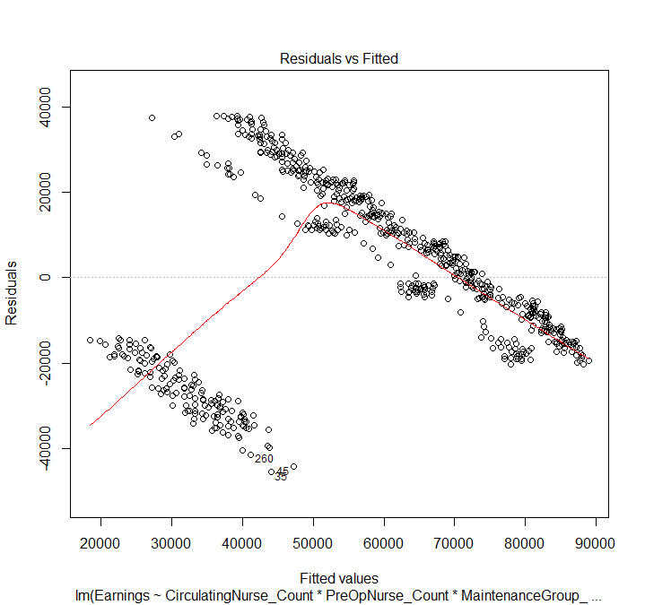

Figure 6: Residuals vs Fitted Plot for the initial model

We noticed that the Residuals vs Fitted plot produced from this linear model was not random and followed an odd pattern in the bottom left and top right cluster. This plot is used to measure the distance of data points from the fitted line and indicate that our regression model specifies an adequate relationship between the earnings and the covariates. Various scenarios were using maximum staff overtime, impeding on profit and providing poor utilization of workers. We deemed that bad data was formed from scenarios that was producing less than $12,000 in earnings. This earning cutoff was identified as the maximum range of this cluster of outlying data. After removing all scenarios under the threshold, another model assessment was made.

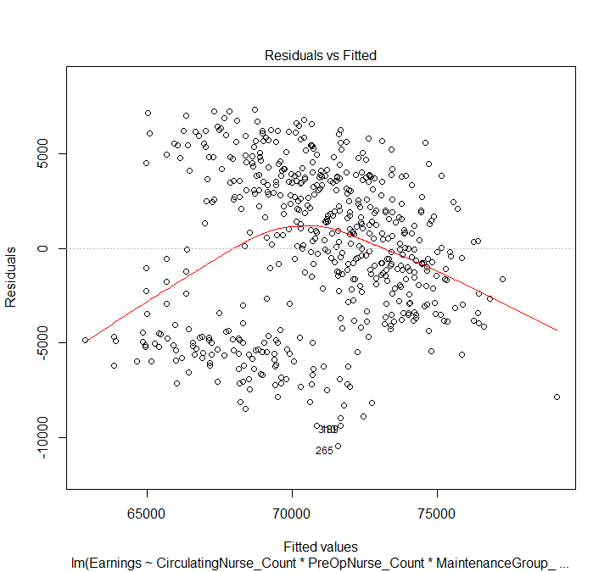

Figure 7: Residuals vs Fitted Plot With Cleaned Data

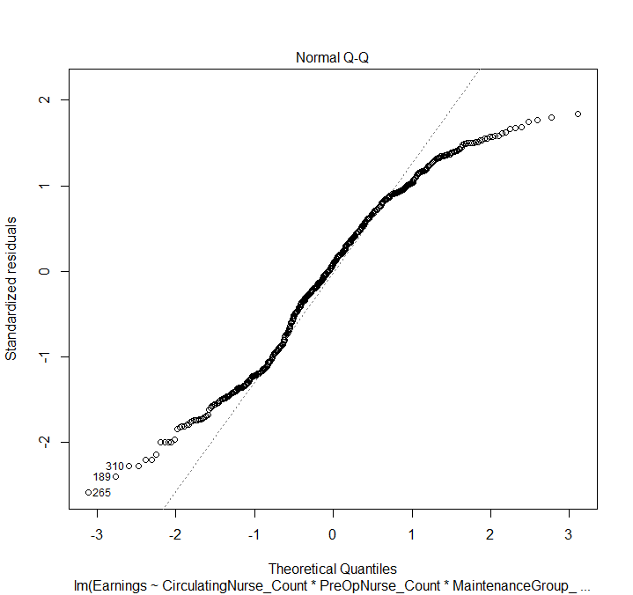

Figure 8: Normal Q-Q Plot to Find If Data Is Normally Distributed

A vast improvement from the previous model was made. While the fitted line in the middle is not straight, we do see that the data points from the curve are more randomly distributed. Additionally, we see that most of the data points follow a normal distribution, which bolsters the support that this model can be analyzed.

While visualizing multivariable linear regression with 5 variables is difficult, we can use a correlation matrix to still show a relation of variables on the dependent variable.

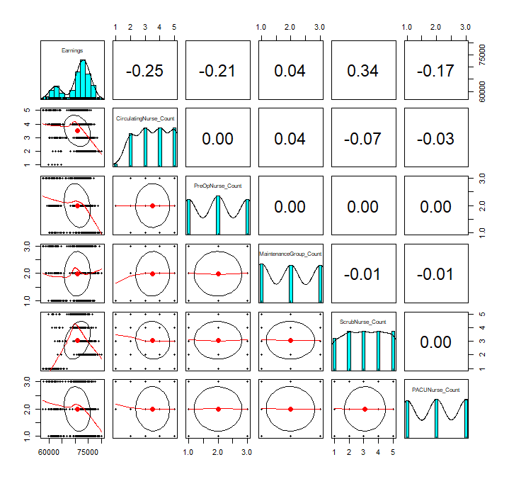

Figure 9: Correlation Matrix Between Dependent and Explanatory Variables

Correlation values range from +1 (perfect positive relation) to -1 (perfect negative relation) with 0 meaning no relation. Noted at the top row, the correlation with earnings and circulating nurse count is -0.25, earnings and PreOP is -0.21 and so on. The correlation for maintenance group and scrub nurse are positive so it makes sense for them to have an increase in staff count as seen in our final staff recommendation seen in Figure 9. It is odd to see a negative correlation of -0.25 between earnings and circulating nurses when our recommendation includes an additional staff member in that department. This is explained by the lack of data the one count circulating nurse data points have since many were removed from the data cleaning in the beginning of this model. Having a two count for circulation nurse is the lowest possible staff count that provided a feasible high earning, which makes sense since it is trying to minimize the negative correlation effect. Additionally, some interaction effects between circulation nurse and other staff members help counteract the negative effect of including not just these nurses, but also all staff. Here are some notable coefficient values (those over three digits):

(Intercept) 84902.76820

CirculatingNurse_Count -3070.15542

PreOpNurse_Count -685.43227

MaintenanceGroup_Count -1815.29331

ScrubNurse_Count -404.83327

PACUNurse_Count -4844.85410

MaintenanceGroup_Count:ScrubNurse_Count 620.35313

CirculatingNurse_Count:PACUNurse_Count 794.21071

MaintenanceGroup_Count:PACUNurse_Count 1381.05619

ScrubNurse_Count:PACUNurse_Count -663.63009

CirculatingNurse_Count:ScrubNurse_Count:PACUNurse_Count 512.80672

Now that we understand that the count of PreOp and PACU nurses have poor correlation to the model, we can simplify our visualization more by just looking at the effects of the other variables. We used a conditioning plot to plot the multiplicative effect of Circulating Nurses, Maintenance, and Scrub Nurses along the introduction of Overtime as an explanatory variable. This allows us to view the interaction effect between these two variables upon the earnings.

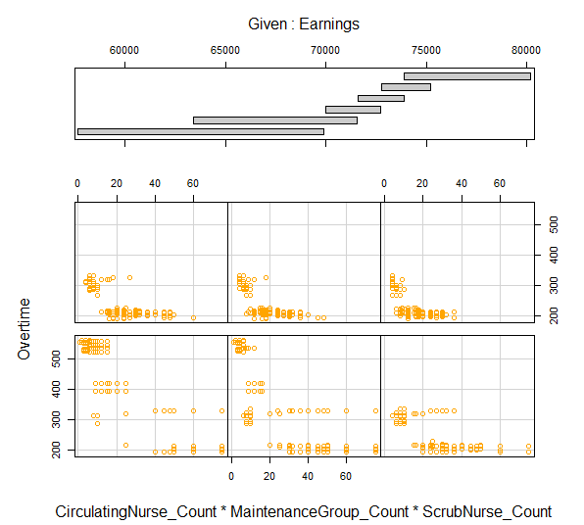

Figure 10: The Conditioning Plot Includes Multi Panel Scatter Plots to Explain the Given Earnings

The top portion of this plot is a bar graph of earnings which has been divided into six clusters based on range. Each cluster is represented by a plot below it, such as the lowest earning cluster represented by the bottom left plot, and the highest earning cluster represented by the top right cluster. We notice that the bottom three plots have a similar pattern and tendency to have greater overtime, which helps explain their lower earnings. The top three plots start to centralize to the bottom left corner more which is explaining lower overtime and lower staff count, which is what the top three clusters have in common.

In order to validate the model further, we created a high face validity Random Forest regressor algorithm to study “Total Earnings” and “Staff Count” accuracy. Random Forest cross-validates the input “branches” of decision-based data and performs a linear regression to find the optimal count. The Random Forest model uses branches of bagging sample data and aggregates these branches to “decide” an optimal count for the parameters mentioned above given our operating room schedule. The simulation model output provides $80,191 in earnings and a 2-1-2-2-1 optimal staff allocation between Circulation Nurses, PreOp Nurses, Maintenance Members, Scrub Nurses, and PACU nurses respectively. Using a training set of 15% of data and 100 branches, we were able to obtain a random forest accuracy of 0.9984 and this output of the highest grossing data:

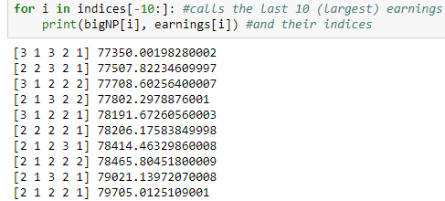

Figure 11: Largest Fitted Earnings and their Indices According to the RF Model

The Random Forest regression model reports having earnings of almost $80,000 which is close to what our data shows. The previous data points under it also show their fitted values which follow a similar trend. For a disclaimer, using 675 points of data for a random forest model is not enough for it to be truly significant and the weight of its validation should be decreased. These series of analysis combined help understand the contribution the support staff make to earnings and why our final recommendation was made with a logical approach in mind.

**References**

1. Sargent, R. (2008). *Verification and validation of simulation models - IEEE Conference Publication*. Ieeexplore.ieee.org
2. Strate, C. (n.d.). *The Cost of a Lost Minute in the OR*. [online] Accessefm.com.
3. Rogers, A., Hwang, W., Scott, L., Aiken, L. and Dinges, D. (2004). *The Working Hours of Hospital Staff Nurses and Patient Safety*. [online] Healthaffairs.org.
4. Santibáñez, Pablo & Begen, Mehmet & Atkins, Derek. (2007). Surgical block scheduling in a system of hospitals: An application to resource and wait list management in a British Columbia health authority. Health care management science. 10. 269-82. 10.1007/s10729-007-9019-6.
5. Weiss, Rebecca. (2014) The Impact of Block Scheduling and Release Time on Operating Room Efficiency. *TigerPrints*, Clemson University , pdfs.semanticscholar.org/5205/b8b6959d749b59e7c3c065ac86ec04d44130.pdf.